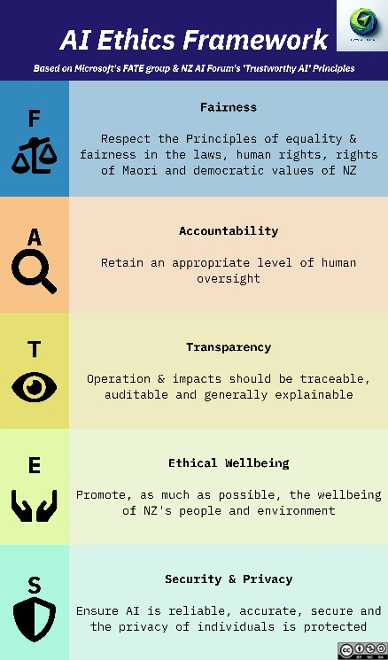
LinkedIn Posts – FATES Ethical Wellbeing
✨ “𝐓𝐡𝐚𝐭’𝐬 𝐧𝐨𝐭 𝐟𝐚𝐢𝐫!” – 𝐀 𝐌𝐢𝐧𝐢-𝐒𝐞𝐫𝐢𝐞𝐬 𝐨𝐧 𝐄𝐭𝐡𝐢𝐜𝐬 𝐢𝐧 𝐀𝐈 ✨
US$700,000 per day to run ChatGPT¹
3.5% of 𝐠𝐥𝐨𝐛𝐚𝐥 𝐩𝐨𝐰𝐞𝐫 use by 2035²
10x the power needed than a google search³
One LLM power facility = minimum energy for 80,000 homes
Re-invigorating nuclear power plants⁴ just to feed server farms

🧑‍⚖️ Today – 𝐄 𝐟𝐨𝐫 𝐄𝐭𝐡𝐢𝐜𝐚𝐥 𝐖𝐞𝐥𝐥𝐛𝐞𝐢𝐧𝐠: 𝐀𝐈 & 𝐭𝐡𝐞 𝐄𝐧𝐯𝐢𝐫𝐨𝐧𝐦𝐞𝐧𝐭
AI isn’t just reshaping business—it’s reshaping global energy demands. In parts of the US, water shortages are worsening as more fresh water is diverted to cool server farms, affecting people, wildlife, and ecosystems. Above are the facts. SO…..
𝐖𝐡𝐚𝐭 𝐜𝐚𝐧 𝐲𝐨𝐮 𝐝𝐨? 𝐘𝐄𝐒 𝐘𝐎𝐔!
💡 Think again – do you really need an LLM for this query?
💡 Opt out of AI search – go to labs.google.com, deselect ‘Ai overviews’ experiment, or even all experiments
💡 Override AI search results – at the end of your search, type -AI to filter out AI-generated content
💡 Turn off unused AI features – check your apps, if they use AI, disable background AI processing.
💡 Install sustainable search - 𝑶𝒄𝒆𝒂𝒏 𝑯𝒆𝒓𝒐 ⁵ search page supports the environment as you use it
💡 Advocate – Share this with your network to raise awareness!

As an organisation consider:
🏭 Build smarter AI – Develop smaller, more efficient models that consume less power
⏳ Schedule AI workloads wisely – Run energy-intensive tasks during off-peak hours
🎯 Train AI Efficiently – Use adaptive training techniques to cut waste
💾 Diversify computing power – Combine hardware types to maximise efficiency
🌍 Use sustainable cloud solutions – Prioritise cloud providers powered by renewables
AI is both a tool and a challenge in the fight against climate change. It can help us optimise energy use, but its own energy demands must be managed responsibly.
𝐖𝐡𝐚𝐭 𝐬𝐭𝐞𝐩𝐬 is your organisation taking to balance AI innovation with sustainability? Let’s discuss! 👇
#EthicalAI #AIForBusiness #AITraining #FATESFramework
_____________________________________________

*this was the latest figure I could find on the web; estimated in 2023 @approx 13 million daily users. Chat-gpt itself guesstimates 142 million daily users now (jan 2025).
Gartner https://www.gartner.com/en/newsroom/press-releases/2023-11-07-gartner-says-cios-must-balance-the-environmental-promises-and-risks-of-ai
https://www.epri.com/about/media-resources/press-release/q5vU86fr8TKxATfX8IHf1U48Vw4r1DZF
https://www.forbes.com/sites/greatspeculations/2024/10/21/why-tech-giants-are-betting-big-on-nuclear-power/
https://oceanhero.today/about-us/how-it-works
https://arxiv.org/abs/2309.13192?utm_source=chatgpt.com

